**Перший рівень**

**1.**

| **Test Scenario** | Check login/registration | | | | | | |
| --- | --- | --- | --- | --- | --- | --- | --- |
|  |  |  |  |  |  |  |  |
| **Step #** | **Step Details** | | **Expected Results** | | **Pass / Fail / Not executed / Suspended** | | |
|
| 1 | Go to main page site  https://automoto.ua/uk | | Main page is opened | | Pass | | |
| 2 | Click to “icon user” top right | | A login/registration pop-up window is opened | | Pass | | |
| 3 | Enter phone number and click “Continue” | | The two-factor authentication window will open | | Pass | | |
| 4 | Enter the 4-digit code from the SMS message received on the specified phone number and click “Continue” | | Login to personal account is complete | | Pass | | |

| **Test Scenario** | Checking the page «Мої оголошення» and adding ads | | | | | | |
| --- | --- | --- | --- | --- | --- | --- | --- |
|  |  |  |  |  |  |  |  |
| **Step #** | **Step Details** | | **Expected Results** | | **Pass / Fail / Not executed / Suspended** | | |
|
| 1 | Go to main page site  https://automoto.ua/uk | | Main page is opened | | Pass | | |
| 2 | Click to “icon user” or “icon star” top right | | A login/registration pop-up window is opened | | Pass | | |
| 3 | Enter phone number and click “Continue” | | The two-factor authentication window will open | | Pass | | |
| 4 | Enter the 4-digit code from the SMS message received on the specified phone number and click “Continue” | | Login to personal account is complete | | Pass | | |
| 5 | Page «Мої оголошення» is opened | | On page «Мої оголошення» displays ads that have been found for your phone number on partner sites | | Fail | | |
| 6 | Go to the page of your ad on the partner platform, for example Auto.Ria  Copy the link to your ad in the format <https://auto.ria.com/uk/auto_mercedes-benz_m-class.html>  Paste the link to ad in the field for url (at the bottom of the add form) and click on the button “Додати” | | The ad is added to the section «Мої оголошення» | | Pass | | |

| **Test Scenario** | Check ad promotion in search results | | | | | | |
| --- | --- | --- | --- | --- | --- | --- | --- |
|  |  |  |  |  |  |  |  |
| **Step #** | **Step Details** | | **Expected Results** | | **Pass / Fail / Not executed / Suspended** | | |
|
| 1 | Go to main page site  https://automoto.ua/uk | | Main page is opened | | Pass | | |
| 2 | Click to “icon user” top right | | A login/registration pop-up window is opened | | Pass | | |
| 3 | Enter phone number and click “Continue” | | The two-factor authentication window will open | | Pass | | |
| 4 | Enter the 4-digit code from the SMS message received on the specified phone number and click “Continue” | | Login to personal account is complete | | Pass | | |
| 5 | Page «Мої оголошення» is opened | | On page «Мої оголошення» displays ads that have been found for your phone number on partner sites | | Pass | | |
| 6 | At the bottom of the ad, click the "Підняти" button | | A window for selecting positions will appear under the "Підняти" button. | | Pass | | |
| 7 | Use the arrows to select the desired ad position, which will be responsible for a certain "Рівень".  Choose the period for fixing the ad.  Click the button “Оплата”. | | The system will redirect to make payment via an available method.  The ad in the publication occupies a selected and paid position. | | Pass | | |

| **Test Scenario** | Checking and paying traffic fines according to the number of the resolution | | | | | | |
| --- | --- | --- | --- | --- | --- | --- | --- |
|  |  |  |  |  |  |  |  |
| **Step #** | **Step Details** | | **Expected Results** | | **Pass / Fail / Not executed / Suspended** | | |
|
| 1 | Go to main page site  https://automoto.ua/uk | | Main page is opened | | Pass | | |
| 2 | Click to section “Ще” on main menu and selected submenu “Оплата штрафів ПДР” | | Page “Сплата штрафів ПДР онлайн за декілька хвилин” is opened | | Pass | | |
| 3 | On form “Перевірка та сплата штрафів ПДР” fill the fields “Серія та номер постанови” and “Номерний знак ТЗ”. Also entered name and e-mail address.  Click the button “Знайти штрафи”. | | Page is opened with a fine according to the resolution | | Pass | | |
| 4 | Click the button “Оплатити”. | | A receipt and a notice of payment of the fine will be sent to the specified email address | | Pass | | |

| **Test Scenario** | Check advanced search | | | | | | |
| --- | --- | --- | --- | --- | --- | --- | --- |
|  |  |  |  |  |  |  |  |
| **Step #** | **Step Details** | | **Expected Results** | | **Pass / Fail / Not executed / Suspended** | | |
|
| 1 | Go to main page site  https://automoto.ua/uk | | Main page is opened | | Pass | | |
| 2 | Click on the advanced search field in the site header | | Page advanced search is opened | | Pass | | |
| 3 | Choose several filters for the search: type of transport, brand, model, price range and etc.  Click the button “Показати”. | | Page with search results is opened. | | Pass | | |

**2.**

* **LIST USERS** Status:200 (OK)Time:54 msSize:1.01 k
* **SINGLE USER** Status:200 (OK)Time:34 msSize:0.27 k
* **CREATE**

Користувач створюється і з ім’ям, і прізвищем, і з двома видами професій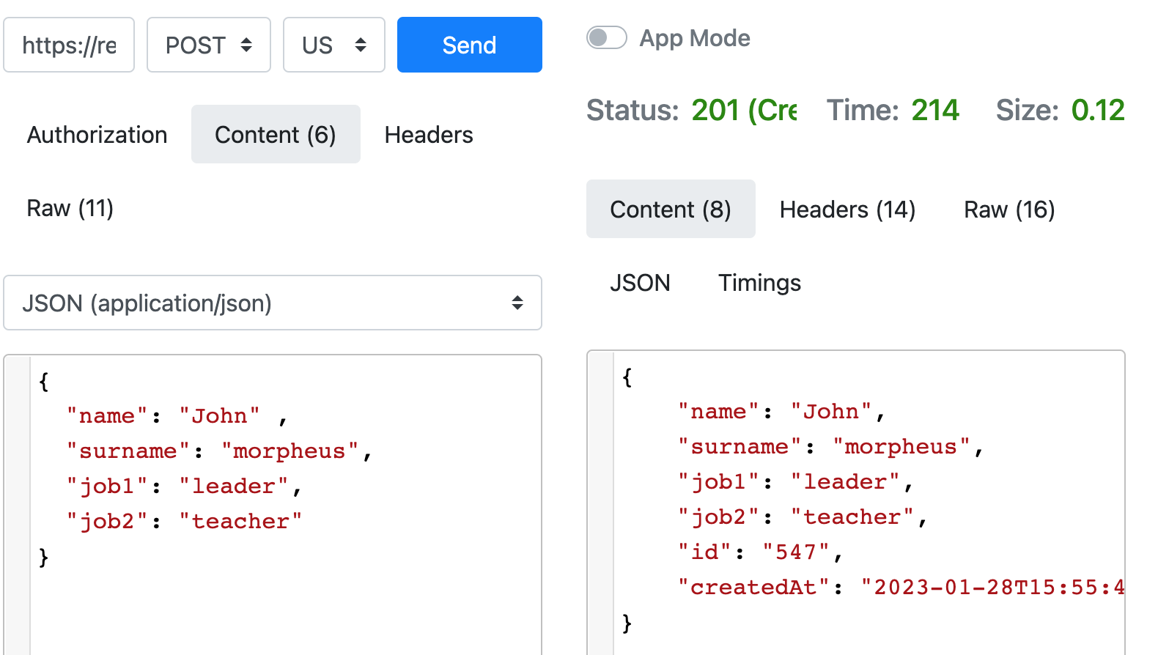

* **UPDATE (PUT)** Status:200 (OK)Time:239 msSize:0.08
* **UPDATE (PATCH)**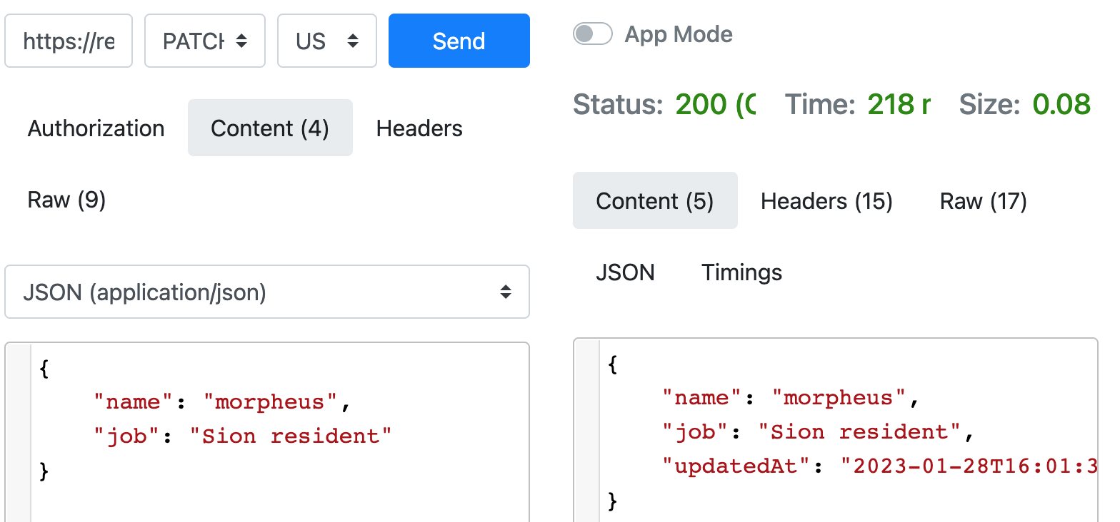
* **DELETE** Status:204 (No Content)Time:215 msSize:0.00
* **REGISTER - SUCCESSFUL**

Якщо змінити email - то отримаємо сповіщення про помилку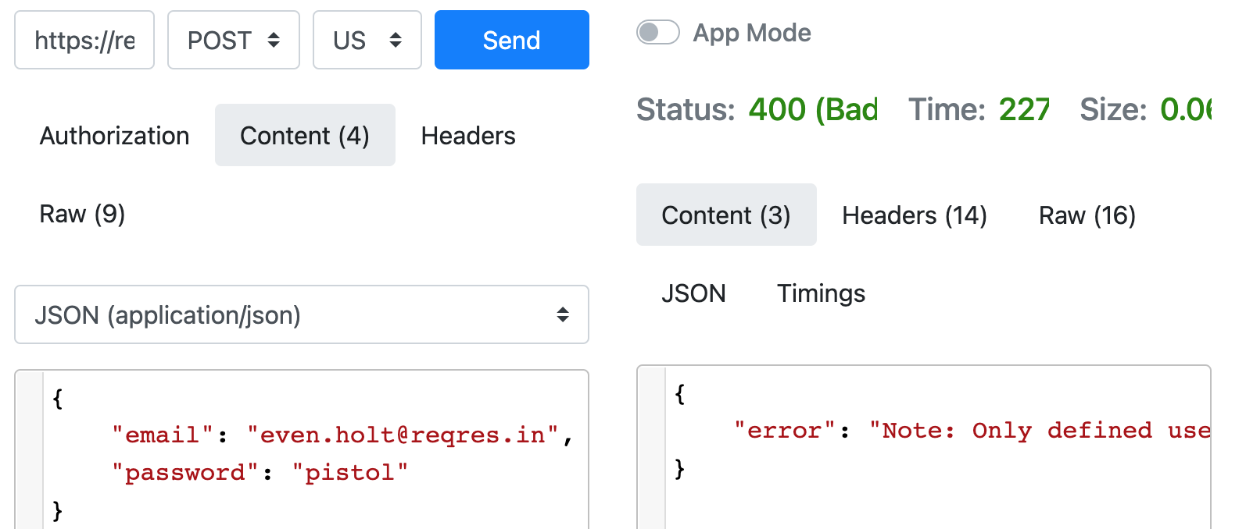

А якщо змінити пароль - то реєстрація проходить, хоча не повинна- це баг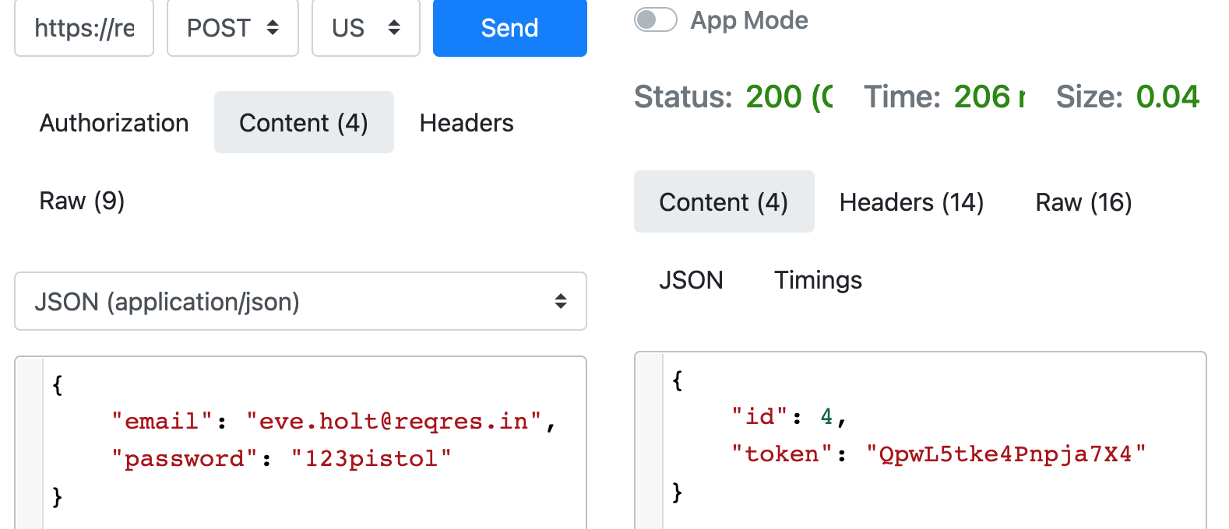

* **LOGIN - SUCCESSFUL**

Якщо змінити email - то отримаємо сповіщення про помилку що користувача не знайдено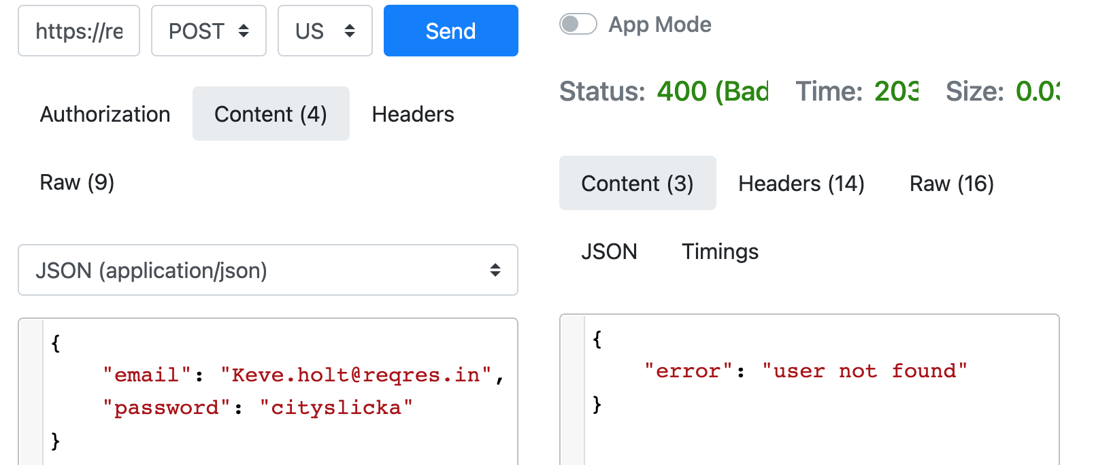

А якщо змінити пароль - то все одно отримуємо токен для входу- це баг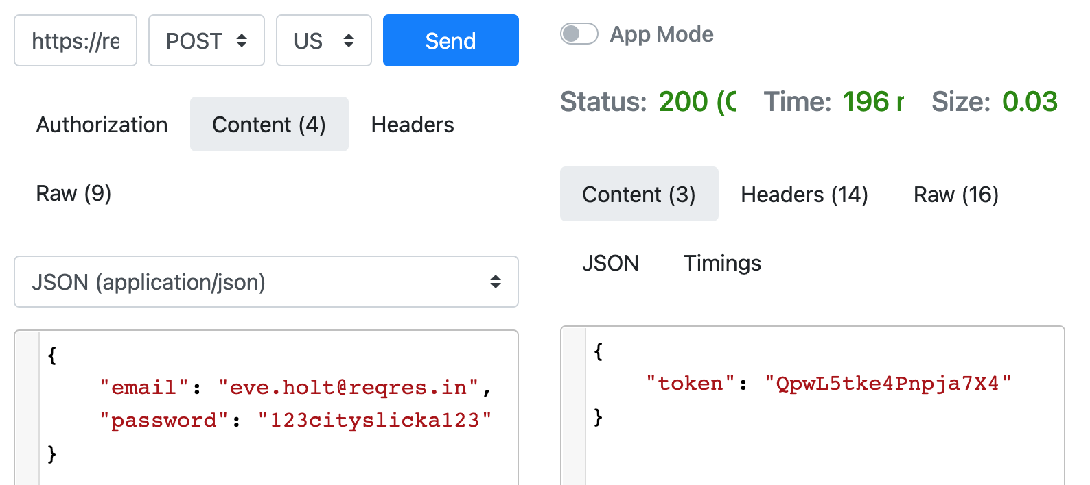

**Другий та третій рівні**

Щось із цим завданням взагалі “засада”...незрозуміло - які саме дані брати і в якому місці devtools порівнювати отриманий результат? наче так і не так виконані спроби нижче, але, будь ласка, поясніть на уроці ще раз - що? куди? і як?

| **POST /public/v2/users** | **Create a new user** |
| --- | --- |

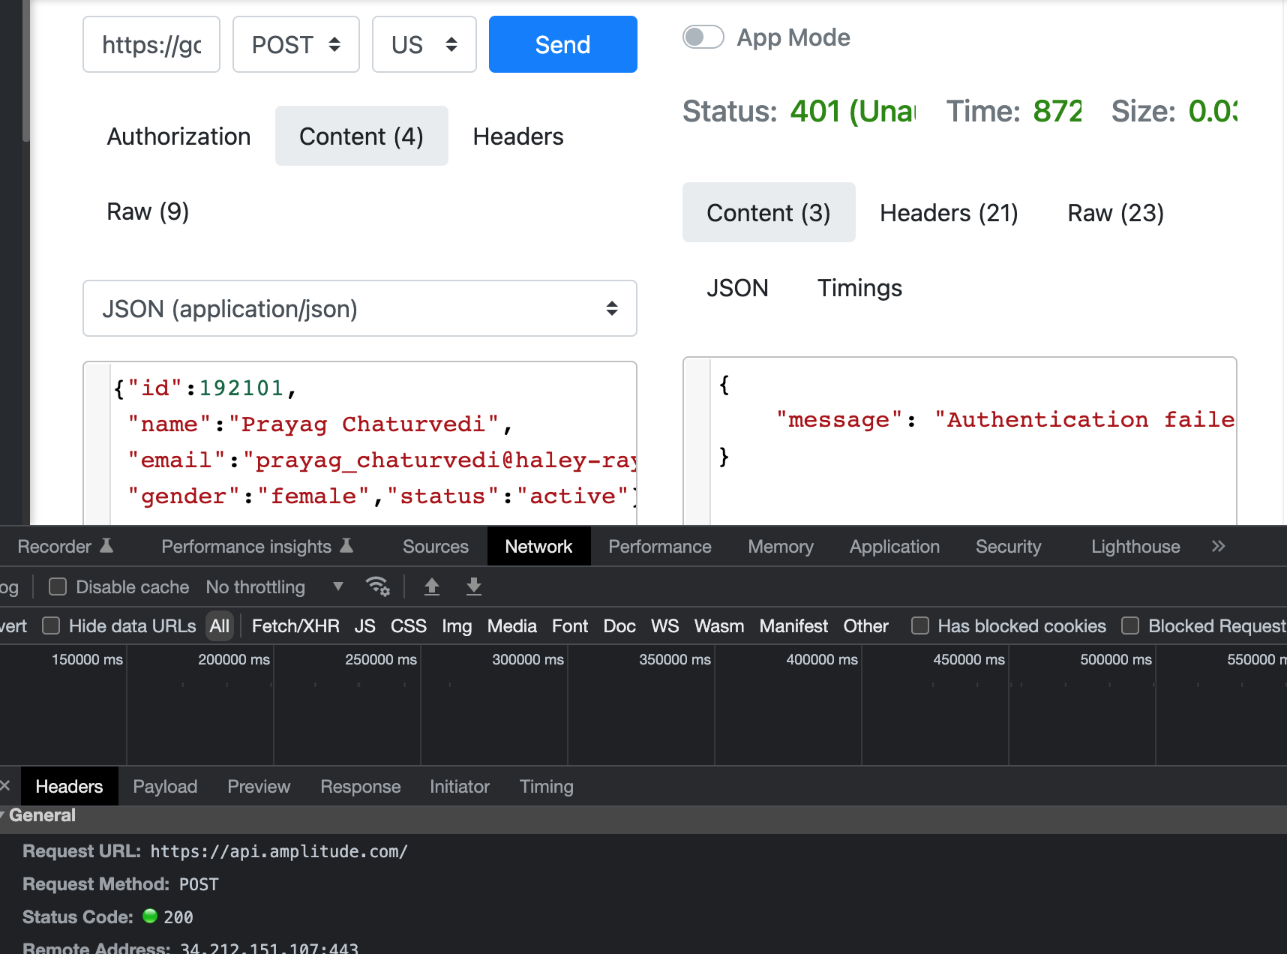

| **GET /public/v2/users** | **Get user details** |
| --- | --- |

